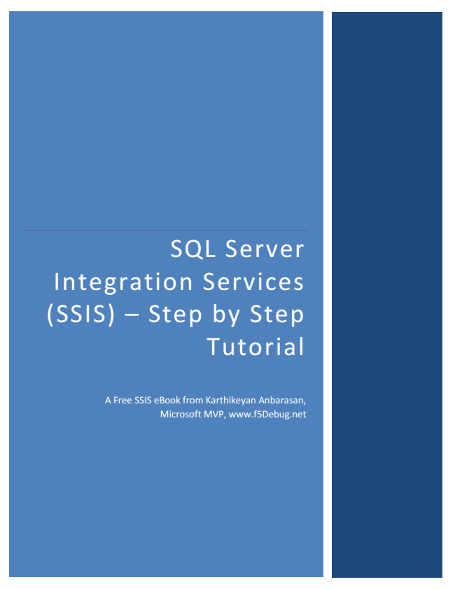

SQL Server Integration Services (SSIS) – Step by Step Tutorial

A Free SSIS eBook from Karthikeyan Anbarasan, Microsoft MVP, www.f5Debug.net

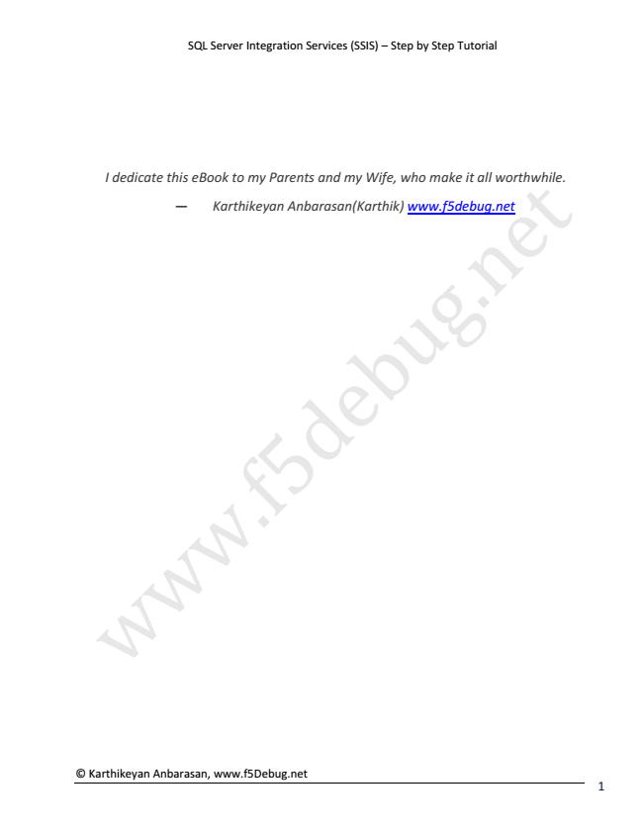

SQL Server Integration Services (SSIS) – Step by Step Tutorial

*I dedicate this — w w eBook Karthikeyan w to my .f Parents Anbarasan(Karthik) 5 and d my e Wife, b*

*who www.f5debug.net*

*u make g*

*it all .n*

*worthwhile. e*

t

© Karthikeyan Anbarasan, www.f5Debug.net

1

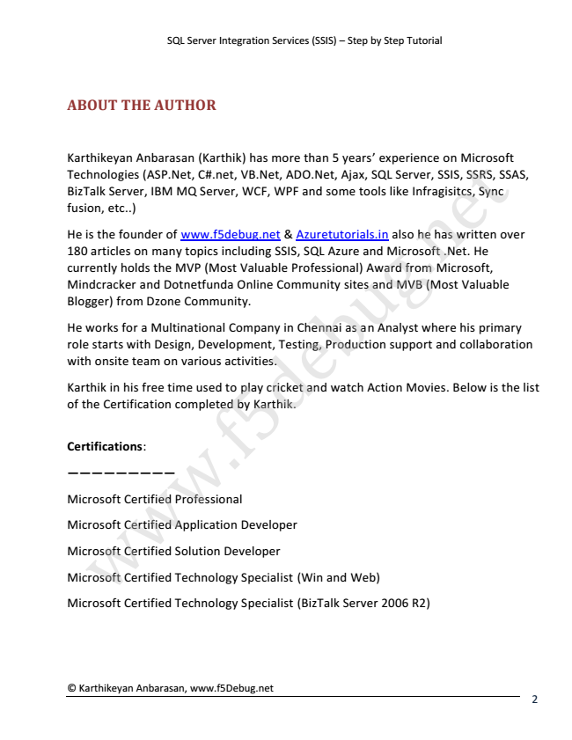

SQL Server Integration Services (SSIS) – Step by Step Tutorial

**ABOUT THE AUTHOR**

Karthikeyan Anbarasan (Karthik) has more than 5 years’ Technologies (ASP.Net, C#.net, VB.Net, ADO.Net, Ajax, BizTalk Server, IBM MQ Server, WCF, WPF and some fusion, etc..)

He is the founder of www.f5debug.net & Azuretutorials.in 180 articles on many topics including SSIS, SQL Azure currently holds the MVP (Most Valuable Professional) Mindcracker Blogger) He role with Karthik of Certifications:

————————— the works starts onsite Certification in from for his with team and a free Dzone Multinational Design, Dotnetfunda on time completed various Community.

used Development, activities. to Company .f Online by play Karthik. 5 cricket Community Testing, in d Chennai and e

Production watch b sites as tools an and Award SQL u and Analyst experience Microsoft like also Server, MVB g from Infragisitcs, he where (Most .n has Microsoft, SSIS, on .Net. written his Microsoft Valuable SSRS, e He

primary Sync t SSAS,

over

support and collaboration

Action Movies. Below is the list

Microsoft Microsoft Microsoft Microsoft Microsoft w

Certified Certified Certified Certified Certified w

Professional Application Solution Technology Technology w

Developer

Developer

Specialist Specialist (Win (BizTalk and Server Web)

2006 R2)

© Karthikeyan Anbarasan, www.f5Debug.net

2

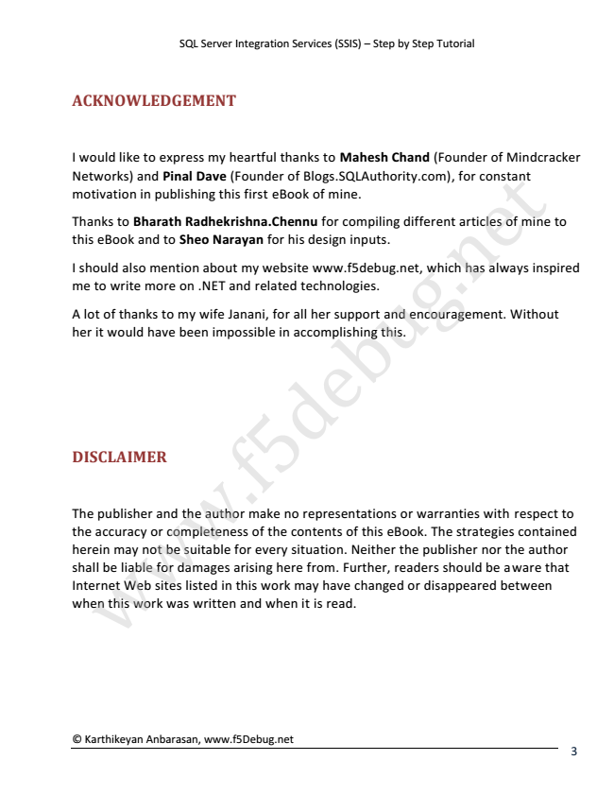

SQL Server Integration Services (SSIS) – Step by Step Tutorial

**ACKNOWLEDGEMENT**

I Networks) motivation Thanks this I me A her DISCLAIMER The the herein shall Internet when would should lot to accuracy it eBook publisher be of would this write may to w thanks like liable also Web Bharath work and and in not to more have mention or publishing sites and for express w to Pinal to be was completeness damages my been Sheo on the suitable Radhekrishna.Chennu listed written Dave .NET wife about w author my impossible Narayan this in Janani, and heartful (Founder arising for this and my first make .f of related every work website when for the eBook for here 5 in thanks no of his contents situation. all accomplishing may technologies. it representations Blogs.SQLAuthority.com), from. design d her of www.f5debug.net, is for have to read. mine. support Mahesh e compiling Further, of inputs. Neither changed this b this. and eBook. Chand readers the u or different or encouragement. warranties publisher disappeared which g The (Founder should strategies for .n articles has constant nor with be always of between e aware the of Mindcracker Without

respect contained mine author t

inspired

that to

to

© Karthikeyan Anbarasan, www.f5Debug.net

3

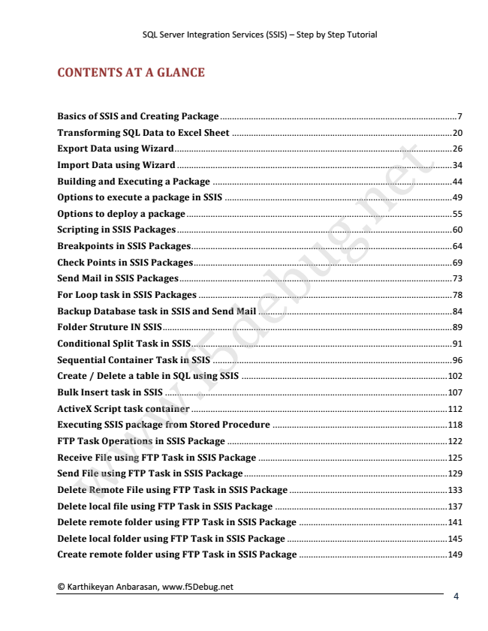

SQL Server Integration Services (SSIS) – Step by Step Tutorial

**CONTENTS AT A GLANCE**

Basics Transforming Export Import Building Options Options Scripting Breakpoints Check Send For Backup Folder Conditional Sequential Create Bulk ActiveX Executing FTP Receive Send Delete Delete Loop Task Insert Mail File Points of Remote local / Struture Data Data w Database Script File to to Delete and SSIS task in using Operations in SSIS execute deploy Container task SSIS Split file using using using SSIS in Executing in and in SQL task package File SSIS w FTP a SSIS IN using in SSIS Packages Task table Packages task Creating a Wizard FTP Wizard Data SSIS SSIS a container using package Task Packages Packages package Packages in Task FTP in in Task in ......................................................................................................................... w a ...................................................................................................................... from to SSIS SSIS SSIS Package in FTP SQL .................................................................................................................... ................................................................................................................... ................................................................................................................... Task Excel .................................................................................................................. in Package SSIS in ............................................................................................................... Package Stored ............................................................................................................. ............................................................................................................. ........................................................................................................... SSIS in and using Task ............................................................................................................ SSIS .f .......................................................................................................... in SSIS Sheet Package Send .................................................................................................... .................................................................................................... SSIS in Package ................................................................................................... SSIS 5 Procedure ............................................................................................... ............................................................................................ SSIS ............................................................................................ Package Mail ...................................................................................... ..................................................................................... d Package ................................................................................. ............................................................................... e ......................................................................... ........................................................................ .................................................................. b u

g

.n

e

t

7

20

26

34

44

49

55

60

64

69

73

78

84

89

91

96

102

107

112

118

122

125

129

133

137

Delete remote folder using FTP Task in SSIS Package .............................................................. 141

Delete local folder using FTP Task in SSIS Package ................................................................... 145

Create remote folder using FTP Task in SSIS Package .............................................................. 149

© Karthikeyan Anbarasan, www.f5Debug.net

4

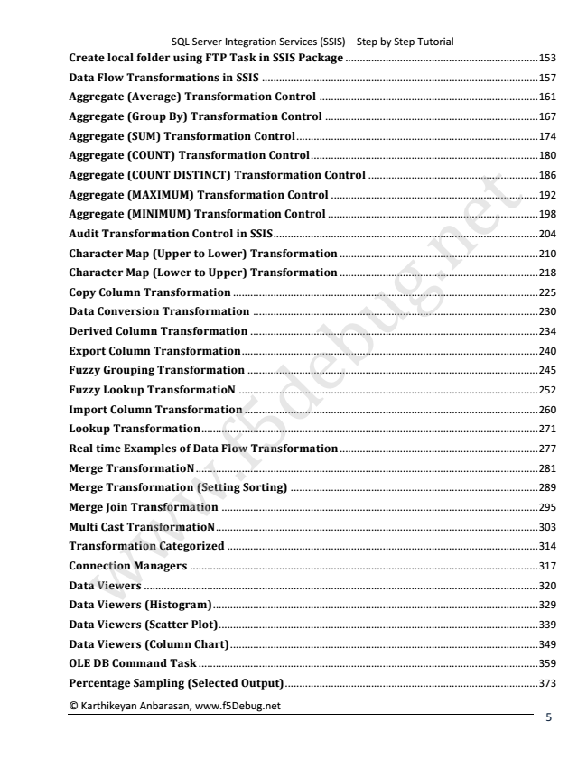

SQL Server Integration Services (SSIS) – Step by Step Tutorial Create local folder using FTP Task in SSIS Package ................................................................... 153

Data Flow Transformations in SSIS ................................................................................................ 157

Aggregate (Average) Transformation Control ............................................................................ 161

Aggregate (Group By) Transformation Control .......................................................................... 167

Aggregate (SUM) Transformation Control .................................................................................... 174 Aggregate Aggregate Aggregate Aggregate Audit Character Character Copy Data Derived Export Fuzzy Fuzzy Import Lookup Real Merge Merge Merge Multi Transformation Connection Data Data time Conversion Viewers Viewers Column Cast Transformation Grouping Lookup TransformatioN Transformation Join Column Column w Transformation Column Examples Map Map TransformatioN (COUNT) (COUNT (MAXIMUM) (MINIMUM) Transformation Managers Transformation ......................................................................................................................................... (Histogram) TransformatioN (Upper (Lower Transformation w Transformation Transformation Categorized Transformation Transformation DISTINCT) Transformation of ......................................................................................................................... Control Data to Transformation to ....................................................................................................................... w (Setting Transformation ..................................................................................................................... Lower) Upper) ................................................................................................................. ................................................................................................................ Flow .............................................................................................................. ............................................................................................................ .......................................................................................................... Transformation in .f ........................................................................................................ ....................................................................................................... Sorting) ...................................................................................................... ..................................................................................................... SSIS............................................................................................ Transformation Transformation .................................................................................................... Transformation ................................................................................................... 5 Control Control Control ...................................................................................... d ............................................................................... Control e ......................................................................... ........................................................................ ..................................................................... ..................................................................... ..................................................................... b ........................................................... u

g

.n

e

t

180

186

192

198

204

210

218

225

230

234

240

245

252

260

271

277

281

289

295

303

314

317

320

329

Data Viewers (Scatter Plot)............................................................................................................... 339

Data Viewers (Column Chart) ........................................................................................................... 349

OLE DB Command Task ...................................................................................................................... 359

Percentage Sampling (Selected Output)........................................................................................ 373

© Karthikeyan Anbarasan, www.f5Debug.net

5

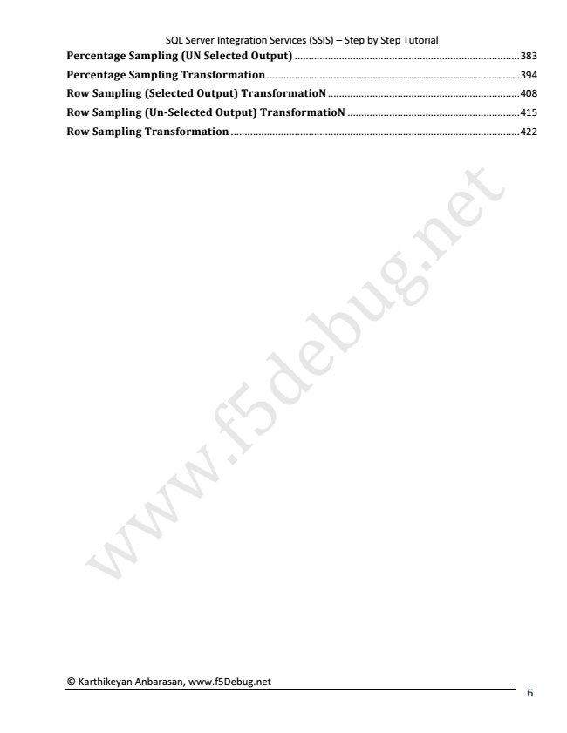

SQL Server Integration Services (SSIS) – Step by Step Tutorial Percentage Sampling (UN Selected Output) ................................................................................. 383

Percentage Sampling Transformation ........................................................................................... 394

Row Sampling (Selected Output) TransformatioN ..................................................................... 408

Row Sampling (Un-Selected Output) TransformatioN .............................................................. 415

Row Sampling Transformation ........................................................................................................ 422

w

w

w

.f

5

d

e

b

u

g

.n

e

t

© Karthikeyan Anbarasan, www.f5Debug.net

6

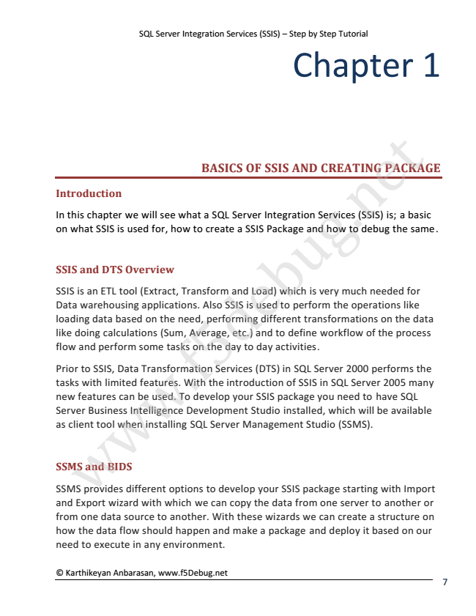

SQL Server Integration Services (SSIS) – Step by Step Tutorial

© Karthikeyan Anbarasan, www.f5Debug.net

Chapter 1

**Introduction**

In on SSIS SSIS Data loading like flow Prior tasks new Server as SSMS SSMS and this client what doing Export is features and and warehousing to with provides and chapter an Business w data SSIS, SSIS tool perform ETL DTS calculations limited BIDS wizard based is Data when can tool w we Overview different used Intelligence be some features. (Extract, will Transformation with applications. on installing for, used. w the see (Sum, which tasks options how need, what To Transform With Development Average, SQL on to .f develop we BASICS Also a create to performing the the Server can SQL 5 Services develop SSIS day introduction copy and Server etc.) your a d Management to SSIS OF is Studio Load) the (DTS) and used SSIS day your different Integration e SSIS Package data activities. to package which to SSIS in installed, b of define AND perform SQL from SSIS package transformations Studio and is u Server you Services very in workflow one CREATING how which SQL the g need (SSMS). server much starting 2000 to Server operations .n (SSIS) will debug to of needed performs to have be the on with 2005 another PACKAGE is; e

available the the process a SQL like

Import

for basic

many same. t

data

the

or from one data source to another. With these wizards we can create a structure on how the data flow should happen and make a package and deploy it based on our need to execute in any environment.

7

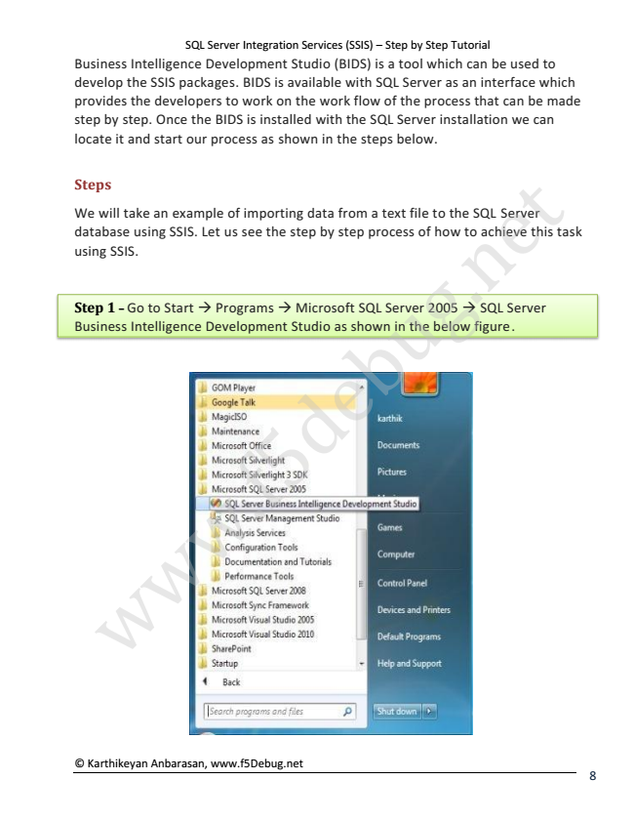

SQL Server Integration Services (SSIS) – Step by Step Tutorial Business Intelligence Development Studio (BIDS) is a tool which can be used to develop the SSIS packages. BIDS is available with SQL Server as an interface which provides the developers to work on the work flow of the process that can be made step by step. Once the BIDS is installed with the SQL Server installation we can locate it and start our process as shown in the steps below.

**Steps**

We will take an example of importing data from a text file to the SQL Server database using SSIS. Let us see the step by step process of how to achieve this task using SSIS.

Step 1 – Go to Start → Programs → Microsoft SQL Server 2005 → SQL Server Business Intelligence Development Studio as shown in the below figure.

w

w

© Karthikeyan Anbarasan, www.f5Debug.net

w

.f

d 5

e

b

u

g

e .n

t

8

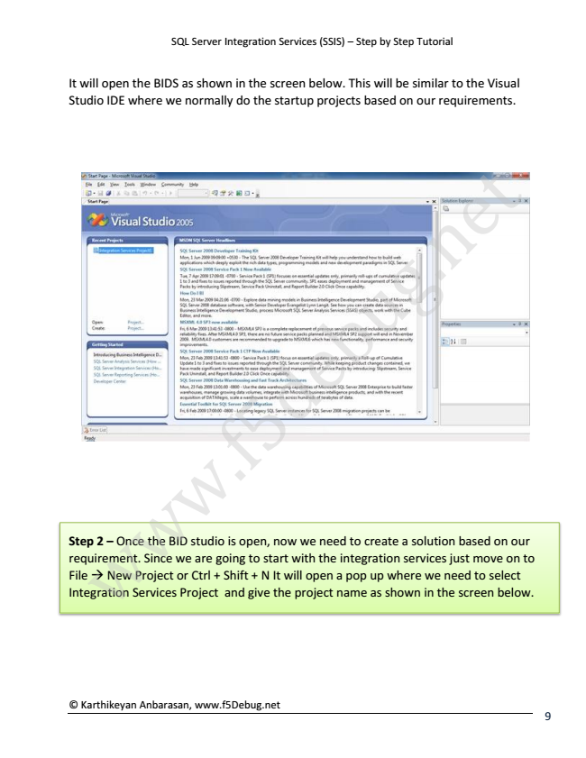

SQL Server Integration Services (SSIS) – Step by Step Tutorial

It will open the BIDS as shown in the screen below. This will be similar to the Visual Studio IDE where we normally do the startup projects based on our requirements.

Step 2 – Once the BID studio is open, now we need to create a solution based on our requirement. Since we are going to start with the integration services just move on to File → New Project or Ctrl + Shift + N It will open a pop up where we need to select Integration Services Project and give the project name as shown in the screen below.

© Karthikeyan Anbarasan, www.f5Debug.net

w

w

w

.f

d 5

e

b

u

g

e .n

t

9